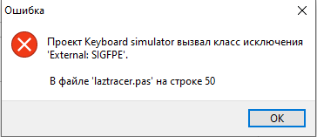

RusCapitalLetters:array of string = ('А', 'Б', 'В', 'Г', 'Д',’Е’,’Ё’,’Ж’,’З’,’И’,’Й’,’К’,’Л’,’М’,’Н’,’О’,’П’,’Р’,’С’,’Т’,’У’,’Ф’,’Х’,’Ц’,’Ч’,’Ш’,’Щ’,’Ь’,’Ъ’,’Ы’,’Э’,’Ю’,’Я’);

RusLowercaseLetters:array of string = ('а', 'б', 'в', 'г', 'д',’е’,’ё’,’ж’,’з’,’и’,’й’,’к’,’л’,’м’,’н’,’о’,’п’,’р’,’с’,’т’,’у’,’ф’,’х’,’ц’,’ч’,’ш’,’щ’,’ь’,’ъ’,’ы’,’э’,’ю’,’я’);

EngCapitalLetters:array of string =(‘A’,’B’,’C’,’D’,’E’,’F’,’G’,’H’,’I’,’J’,’K’,’L’,’M’,’N’,’O’,’P’,’Q’,’R’,’S’,’T’,’U’,’Y’,’W’,’X’,’Y’,’Z’);

EngLowercaseLetters:array of string = (‘a’,’b’,’c’,’d’,’e’,’f’,’g’,’h’,’I’,’j’,’k’,’l’,’m’,’n’,’o’,’p’,’q’,’r’,’s’,’t’,’u’,’y’,’w’,’x’,’y’,’z’);

Прототип <https://www.figma.com/file/eVMAiZlBKckRbT0vkCcHxi/Untitled?node-id=0%3A1>